|  |
| --- |
| Progress Report  By Atomic Peanuts © |

|  |
| --- |
|  |





Louis Kareem Cocks (Project Leader & Developer) S.N: 3954358

Jose Navarrete Carbonell (Developer) S.N: 3917533

Table of Contents

Progress Table 2

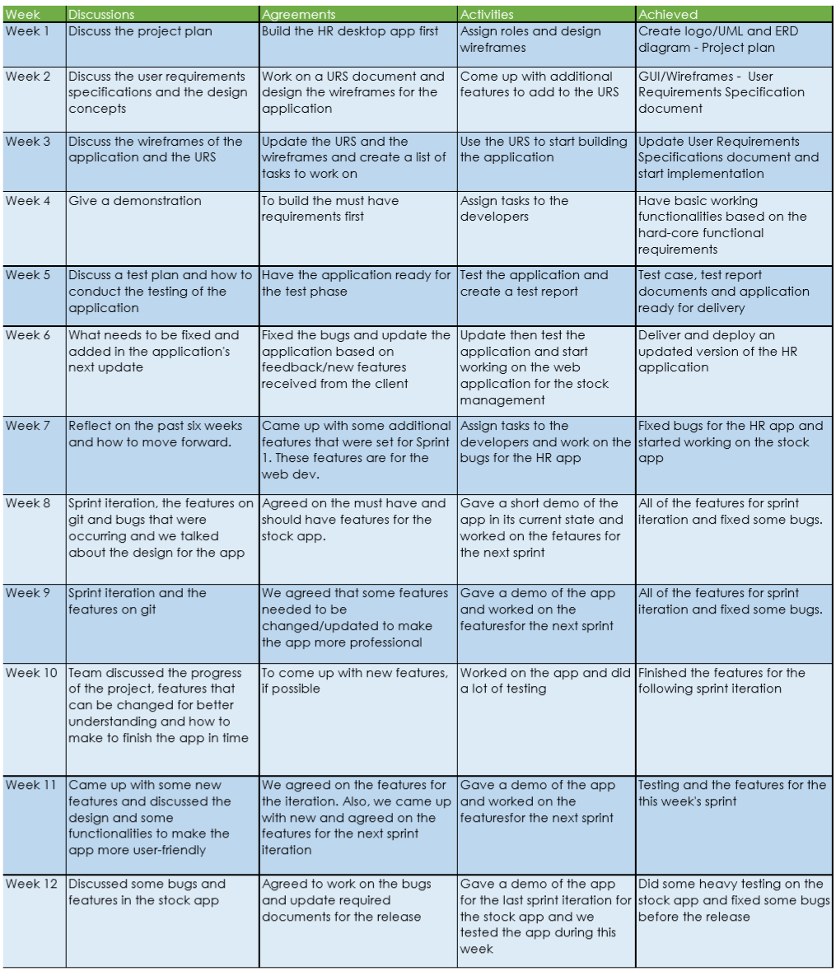

# Progress Table